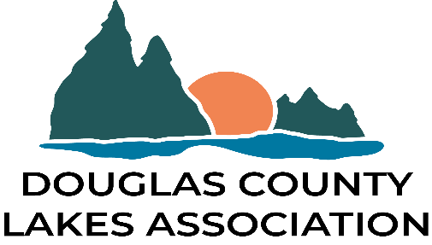

BOARD of DIRECTORS MEETING MINUTES
WEDNESDAY, May 8, 2019
Douglas County Public Works Bldg.
The Board meeting was held in attendance were the following: Steve Henry Le Homme Dieu, Gene Rose -Miltona, Linda Dokken McFann-Mary, Dick Sudmeiers-Ida, Diane Lopez-Ida, Cynthia Fuller-Victoria, Rod Johnson-Lobster, Jessica Albertsen-SWCD, Randy Meyer-Jessie, Carol-Weber Brown-LeHommeDieu, Donna Pedersen-Brophy, Jerry Rapp-County Commissioner, Anderson-Paul Chippewa, D.P. Wheeler-Latoka, Bonnie Huettl-Lobster.
President Henry called the meeting o order at 4:30 p.m. The agenda was approved by Linda Dokken McFann and Rod Johnson. Minutes from the April 10 meeting were approved by Dick Sudmeiers and Randy Meyers. Jim Peterson was absent but Steve Henry gave the repot. Gene Rose and Cynthia Fuller approved the report to be placed in file for audit.
Committee Reports:
a. Water Quality Legacy Fund - Gene Rose reported that the Technical Committee will have the first meeting May 16,2019. He has spoken to Leah Hall regarding fund raising such as who can be contacted for donations. She cannot give out a list but will assist in compiling contacts. The fact sheets to be are still in progress. There will be 2 different versions. One directed to Douglas County the other will be more board in appeal.
b. SWCD-Jessica Albertsen reported their activities. The tree handout was a huge success, trees have been picked up and plantings have begun. Thank you to all who ordered we sold out. Buffer checks are underway and flagging is being done as well. Surveying potential shorelands projects around the County. School year is wrapping up. Summer school is about to begin for Education. Conservation Tour is being planned. Going to multiple newsletter a year vs. 2 small and one main) Recreational maps are being updated and printing is in progress. County Fair promotional items are in. This year’s theme is back to Water Quality and AIS. See newsletters for additional updates. And information. It is a national Restore a wetland month! Kids Groundwater was a huge success. We had 512 students attended. CSP (Conservation Stewardship Program) deadline is May 10. 2-4 Wetland Restoration inquiries per day Attended 1W1P Mtg for Long Prairie, Sauk, Pomme de Terre and Chippewa River Watersheds. No specific projects on lakes has been identified.
c. Land & Resources -no report.
d. Communication -The Thursday after our Board meeting is the dedicated time for Open Line, on KXRA radio, to promote DCLA and water quality. This month Mitch Lawler, Conservation Officer, will be the guest. President Henry asked for suggestions of whom to invite for this time.
OLD BUSINESS
a.Web Launch- Cynthia Fuller is the new Web Administrator. If you see something that needs correcting please send her an e mail with ‘DCLA ‘in the subject line. (cynsful@gmail.com)

b. Chloride Testing-DCLA will pay for one testing site for lakes that are currently monitored to determine a baseline measurement. Only testing onetime this year.
ALASD monitors the city lakes only.
NEW BUSINESS
Dates of Annual Meetings: Steve H will be attending the Latoka Annual meeting to present ‘Our Lakes Our Future”. He would like to attend more meetings to spread the word about WQLF.
From the floor…
Meet at the Bemo Building on the Fair grounds to carpool at 6:30. The Viking Sportsmen is sponsoring a tour of the Fish Hatchery in Glenwood Thursday May15.
Jerry Rapp suggested that DCLA present the Our Lakes Our Future to bait dealers.
Rod Johnson-spoke about the Echo Press article on leaking manure pits. Who is watching.?. Answer SWCD. Discussion ensued. Linda Dokken-McFann asked if the Feedlot Officer about who monitors a non-compliant feedlot.
Rod Johnson and Dick Sudmeiers motioned to adjourn the meeting

Respectfully submitted;
Bonnie Huettl, DCLA-Secretary

